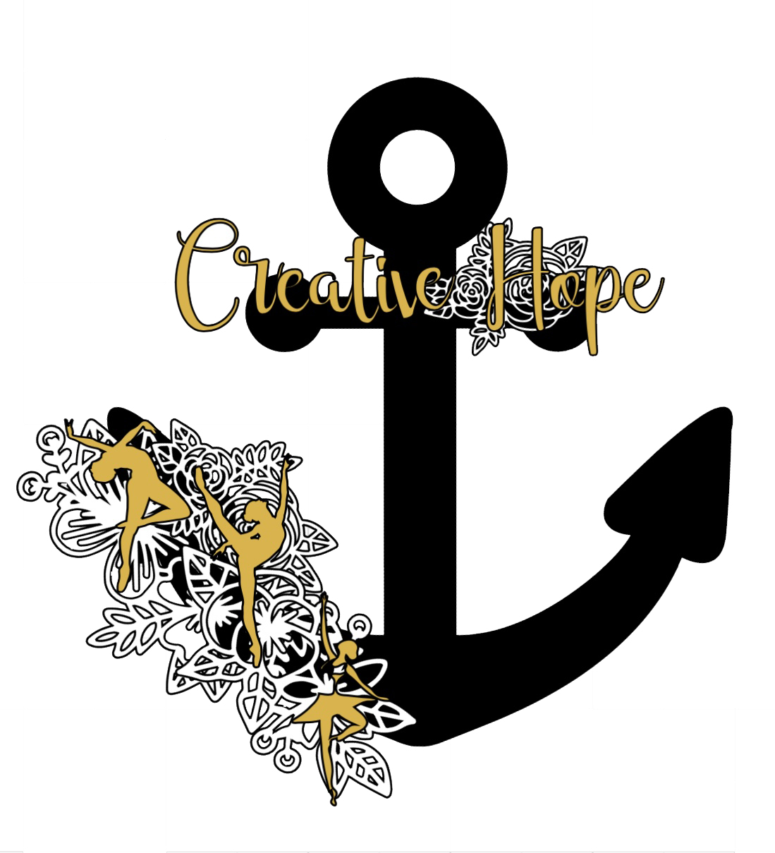Creative Hope Academy of dance Registration form Summer 2021

Student Name: ____________________________________________________
Date of Birth: ______________________ School Grade: __________________
Medical Info/ Health Concerns: _______________________________________
Parent/ Guardian Name: _____________________________________________
Mailing Address: ____________________________________________________
City: ____________________ State: _____________ Zip Code: _______________
Phone Number: _____________________________________________________
Email: _____________________________________________________________

Emergency Contact Name: ____________________________________________
Phone Number: _____________________________________________________
Relationship to student: ______________________________________________

Medical Release
In the event you are unable to reach me, in the case of injury or accident, I give my permission for treatment as deemed necessary by staff or emergency personnel. I also release Creative Hope Academy of Dance and its staff of liability in case of injury or accident incurred to:

Child name: ________________________________________________
Parent/ Guardian Signature: ___________________________________
Date: ____________________

Permission to use Students photos on the internet

___ I give Creative Hope permission to use my Child’s photo on the internet _______ (initial)
___ I DO NOT give Creative Hope Permission to use my child’s photo on the internet. ______ (Initial)

Previous Dance Experience
Years: _________________________ Where: ______________________________________________
ALONG WITH THE POLICIES AND PROCEDURES, I HAVE READ, UNDERSTAND AND AGREE TO FOLLOW THE ATTACHED REGISTRATION AGREEMENT OF BREAKING POINTE DANCE STUDIO.
Signature___________________________________________________Date:_____________
Summer 2021 Creative Hope Academy of Dance Information and Policies
Class Fees
- Drop in class fees must be paid before dancer can enter the dance floor
- Summer camp fees must be paid in full at the start of the camp week
- Payments accepted in the form of Cash or Checks made payable to Casey Crider or Creative Hope Academy of Dance
- Please include child’s full name in the check memo
- There is a returned check bank fee of $25
Insurance
- Creative Hope Academy of Dance does not carry health insurance for its students. It is recommended each student be covered by their own family insurance policies and if occurs it is understood that the student’s insurance will be their only form of reimbursement
Dress Code
- Young Dancers
  - Any Color Leotard
  - Ballet Skirt/ Jazz shorts
  - Convertible tights pink or skin-tone
  - Proper shoes required for each class, ask about what you need before you order! (We can order for you as well!)
- Open Classes
  - Moveable clothing
  - Dance shoes of choice
- NO STREET SHOES ALLOWED ON OUR STUDIO FLOOR
Studio Rules
- Students should be dressed properly and ready for class for start time
- If your student is late without warning, we will do our best to accommodate but please understand safety is of our utmost concern
- Please arrive 5-10 minutes before class time to allow for proper preparations
- No cellphones, loose jewelry or street shoes allowed
- Absolutely no chewing gum in the studio allowed
- Only covered beverages allowed in studio
- Snacks allowed in the waiting room only
- Children should not be left unattended in the waiting area before or after class
- If you are late picking up your child, please call the studio and let us know. If you are later than 15 minutes with no warning, your account will be charged an aftercare fee
- We must know who is picking up your child, if the person is not listed, we cannot allow the child to leave our care.
- The studio is not held responsible for any child that leaves the premises
- Students, parent, and teachers should pick up after themselves, DO NOT bring valuables into the studio. We are not held responsible for lost or stolen items
- Students, parents and teachers are expected to conduct themselves with respect for each other at all times. A co-operative environment is essential for learning.
- We reserve the right to refuse service to anyone
- We will follow a three-strike rule:
  - first strike- warning
  - second strike- message to parents
  - third strike- child must sit or will be dismissed from the classroom

